PROJECT TITLE:

HALO (Heatstroke Alert & Life-saving Organizer)

TEAM MEMBERS:
· Sivaarunmani G K
· Haritha K
· Sanjaay Manikandan M
· Sangamithra B

List of hardware components used:
· Breadboard
· DHT 22 -Humidity and Temperature Sensor
· G-MOD:WS2812B Addressable RGB LED RING [37 LED]
· Glyph C6
· LDR (5mm Light Dependent Resistor)
· SW420 Vibration Sensor

Pin configuration and circuit connections:

1. DHT22 (Temperature + Humidity Sensor)
VCC → 3.3V
GND GND
DATA → GPIO14 (DHTPIN in code)
(Use a 10k pull-up resistor between DATA and VCC for stable signal.)
2. LDR (Light Sensor)
If you're using just LDR + resistor (voltage divider):
One leg of LDR → 3.3V
Other leg of LDR → GPIO1 (LDR_PIN in code)
That same leg also → Resistor (10k) → GND
GPIO1 reads the analog voltage (0-3.3V) depending on light.
3. Vibration Sensor (SW-420 or similar)
If it's a digital vibration sensor module:
VCC → 3.3V
GND GND
OUT → GPIO20 (VIB_PIN in code)

Circuit design/schematic diagrams:

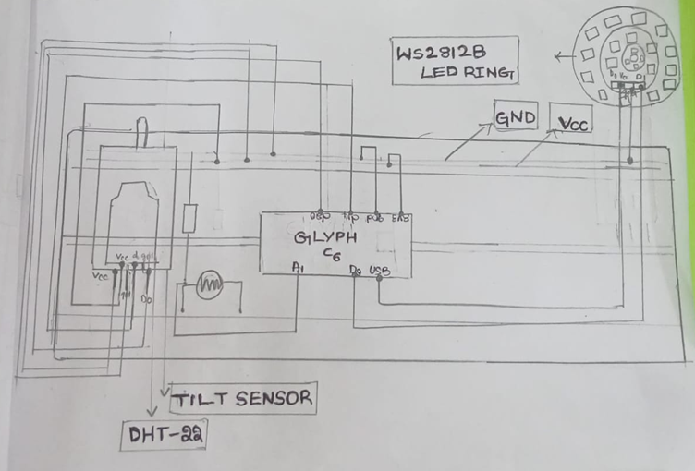

Code :
#include <WiFi.h>
#include <HTTPClient.h>
#include <Wire.h>
#include <DHT.h>
#include <ArduinoJson.h>
#include <Adafruit_NeoPixel.h>

const char* WIFI_SSID = "Haritha";
const char* WIFI_PASS = "haritha.k";

const char* FIREBASE_HOST = "https://halo-16bfd-default-rtdb.asia-southeast1.firebasedatabase.app/";
const char* FIREBASE_AUTH = "etMqyyz3AsfjbXaDPkPAcErHER9PjRgJEJW3nlXI";

const unsigned long UPLOAD_INTERVAL = 3000; // 3 sec

#define DHTPIN 14
#define DHTTYPE DHT22

#define VIB_PIN 20
#define LDR_PIN 1

#define LED_PIN 8
#define NUM_LEDS 37

DHT dht(DHTPIN, DHTTYPE);
Adafruit_NeoPixel ring(NUM_LEDS, LED_PIN, NEO_GRB + NEO_KHZ800);

unsigned long lastUpload = 0;

String firebasePut(const String &path, const String &jsonPayload) {
String url = String(FIREBASE_HOST) + String(path);
if (String(FIREBASE_AUTH).length() > 0) url += "?auth=" + String(FIREBASE_AUTH);

HTTPClient http;
http.begin(url);
http.addHeader("Content-Type", "application/json");
int httpCode = http.PUT(jsonPayload);
String payload = (httpCode > 0) ? http.getString() : "HTTP_ERROR_" + String(httpCode);
http.end();
return payload;
}

void setRingColor(uint8_t r, uint8_t g, uint8_t b) {
for (int i = 0; i < NUM_LEDS; i++) {
ring.setPixelColor(i, ring.Color(r, g, b));
}
ring.show();
}

void setup() {
Serial.begin(115200);
delay(100);
Serial.println("Glyph C6 monitor starting...");

dht.begin();
delay(2000);

pinMode(VIB_PIN, INPUT_PULLUP);
analogReadResolution(12);

ring.begin();
ring.setBrightness(80);
setRingColor(0, 0, 0);

WiFi.begin(WIFI_SSID, WIFI_PASS);
Serial.print("Connecting to WiFi");
unsigned long tstart = millis();
while (WiFi.status() != WL_CONNECTED && millis() - tstart < 20000) {
delay(500); Serial.print(".");
}
Serial.println(WiFi.status() == WL_CONNECTED ? "\nWiFi connected" : "\nWiFi failed!");
lastUpload = millis();
}

void loop() {
unsigned long now = millis();

float tempC = dht.readTemperature();
float hum = dht.readHumidity();
int ldrValue = analogRead(LDR_PIN);
float ldrPercent = (ldrValue / 4095.0) * 100.0;
bool vib = (digitalRead(VIB_PIN) == LOW);

if (isnan(tempC) || isnan(hum)) {
Serial.println("DHT reading failed!");
return;
}

String status = "safe";

if (tempC > 38 || (tempC > 34 && hum > 75)) {
status = "danger";
setRingColor(255, 0, 0);
}
else if ((tempC > 32 && tempC <= 38) || (tempC > 30 && hum > 65)) {
status = "warning";
setRingColor(255, 80, 0);
}
else {
status = "safe";
setRingColor(0, 150, 0);
}

Serial.println("----- SENSOR DATA -----");
Serial.print("Temperature (C): "); Serial.println(tempC);
Serial.print("Humidity (%): "); Serial.println(hum);
Serial.print("LDR Raw: "); Serial.print(ldrValue);
Serial.print(" ("); Serial.print(ldrPercent); Serial.println("%)");
Serial.print("Vibration: "); Serial.println(vib ? "active" : "inactive");
Serial.print("Status: "); Serial.println(status);
Serial.println("-----------------------");

if (now - lastUpload >= UPLOAD_INTERVAL) {
lastUpload = now;
Serial.println("Uploading to Firebase...");
Serial.println(firebasePut("/sensor/temperature.json", String(tempC)));
Serial.println(firebasePut("/sensor/humidity.json", String(hum)));
Serial.println(firebasePut("/sensor/sunlight.json", String(ldrPercent)));
Serial.println(firebasePut("/sensor/vibration.json", vib ? "\"active\"" : "\"inactive\""));
Serial.println(firebasePut("/sensor/status.json", "\"" + status + "\""));
}

delay(1000);
}

Software/tools used:
· Arduino IDE

Clear pictures of the setup/prototype:
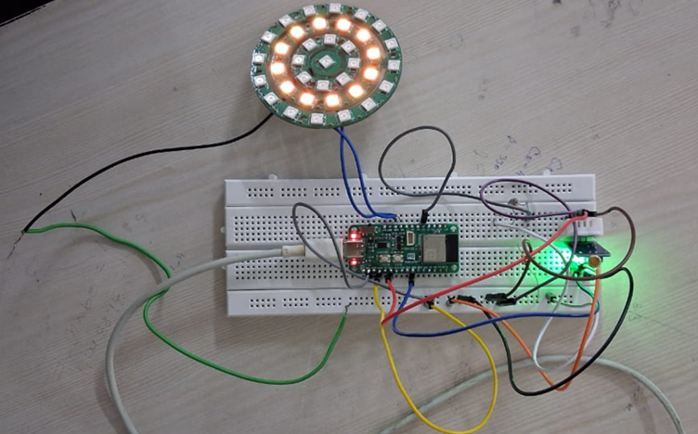

Working explanation and output:
1. Power & Ground

· All modules (DHT22, LDR, SW-420, WS2812) share common GND.
· Use 3.3V from the ESP32/Glyph board to power sensors and LEDs (limited number).

2. DHT22 – Temperature & Humidity

· Reads ambient temperature (`T`) and humidity (`RH`).
· Computes heat index (perceived temperature).
· Minimum read interval ~2 seconds; retry 2–3 times if reading fails (`NaN`).
· Output → contributes main risk factor.

3. LDR – Light Sensor

· Measures ambient light via voltage divider (LDR + 10kΩ resistor).
· ADC reading normalized `0.0–1.0` → `sunScore`.
· If `sunScore > 0.6`, add small offset (+2°C) to heat index → accounts for sunlight exposure.

4. SW-420 – Vibration / Movement Sensor
· Detects movement spikes.
· Track last movement using `millis()`..
· If no movement for 5 min → inactivity offset (+1) applied to risk.

5. WS2812 – Visual Indicator
· LED color shows risk level
· Green → Safe
· Yellow → Caution
· Red → High / Danger
· Risk level calculated as:
```
· riskValue = heatIndex + sunOffset + inactivityOffset
```

6. Logic Flow

· Read DHT22 → heat index (`HIc`).
· Read LDR → calculate `sunScore` → add sun offset if bright.
· Read SW-420 → detect movement/inactivity → add inactivity offset.
· Combine → `riskValue` → map to LED color.
· Repeat every ~8 seconds for live monitoring.

7. Important Notes

*No RTC needed; `millis()` handles relative time for inactivity.
*Works real-time, suitable for alerts.
* Keep LED count small and brightness low to avoid overloading 3.3V rail

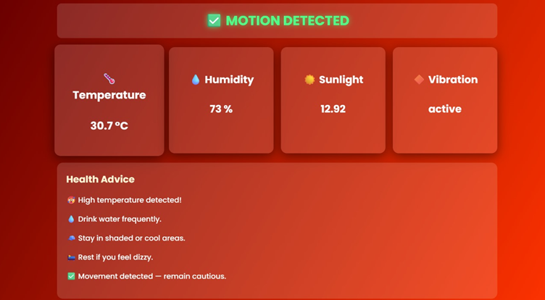

Applications and other relevant details:
- Heatwave & Climate Safety Monitor
  - Detects extreme heat/humidity using DHT22 → warns users about dehydration risk.
  - Links to global warming awareness (rising heat → rising health risks).
- Personal Health & Safety Band
  - Monitors body/environment conditions.
  - Alerts if fall/shock detected (SW-420 vibration sensor).
- Workplace Safety
  - For outdoor workers, construction staff, farmers: band can signal unsafe temperature + light exposure.
- Disaster Preparedness Gadget
  - Can log data with RTC for post-event analysis.
  - Example: in a heatwave/flood relief camp, volunteers can wear it.
- Smart Energy & Awareness Tool
  - LDR can track sunlight exposure → optimize working hours outside.
  - Encourages people to reduce exposure → connects to climate change mitigation.
- Low-Cost Environmental Logger
  - With WiFi/cloud, can act as a distributed IoT node measuring environment across different areas.
- Smart Home / Daily Use
  - Alerts with LEDs if humidity/temp crosses threshold → useful for elderly/children.

Other Relevant Details
- Sensors Used & Their Roles
  - DHT22: Accurate temp/humidity (±2% RH, ±0.5°C).
  - LDR: Simple light detection → cheap way to measure sun exposure.
  - SW-420: Motion/fall detection (simple digital trigger).
  - RTC PCF8563: Keeps accurate time for logging events.
  - WS2812 LEDs: Attractive visual alerts (color-coded for severity).
2. Advantages
=> Low-cost & portable.
=> Works offline (LED alerts) and online (data logging).
=> Combines environmental + safety monitoring.
=> Can be worn → high user interaction & demo appeal.
- Limitations
=> DHT22 has slower response time (sampling every ~2s).
=> SW-420 is noisy → needs software debouncing.
=> Power consumption (WS2812) is high → limit brightness.
=> Breadboard/perfboard version may not be durable → need enclosure.
- Improvements Possible
=> Add GPS → track heat zones.
=> Add WiFi/Firebase logging (Glyph supports it).
=> Replace SW-420 with MPU6050 (more accurate fall detection).
=> Power optimization for longer wearable use.
- Connection to Global Warming / Novelty Angle
  - Rising heatwaves and UV exposure → need personalized alert systems.
  - Your band is like a “climate-aware guardian” on the wrist.
  - Judges will connect emotionally: “Imagine a farmer collapsing under heat stress — this band can warn him early and save lives.”

